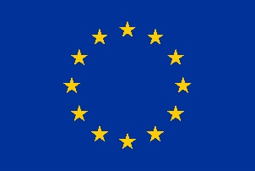
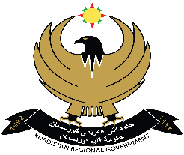
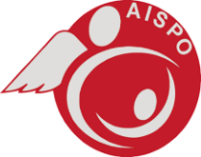

8th March 2018
EU REGIONAL TRUST FUND ‘MADAD’
LETTEr of invitation to tender

OUR REF: AISPO/EU-MADAD/Me/09

To whom it may concern,

SUBJECT: Supply of biomedical equipment for Heevi Paediatric Hospital in Duhok, Autonomous Region of Kurdistan (Iraq)

This is an invitation to tender for the above mentioned supply contract. Please find the following documents, which constitute the tender dossier:
- Contract Notice
- Instruction to tenderers
- Draft contract and special conditions, including annexes:
- Draft contract \ special condition (please note that the contract is a draft and may be subject to minor changes)
- Annex I: general conditions
- Annex II + III: technical specification + technical offer
- Annex IV: budget breakdown (model financial offer)
- Further information
- Administrative compliance grid
- Evaluation grid
- Tender form for a supply contract
- Tender Form
- Annex 1: Declaration of honour on exclusion and selection criteria
- Legal Entity form
- Detail of Bank account form
For full information about the procurement procedures please consult the Practical Guide and its annexes, which can be downloaded from the following web page: http://ec.europa.eu/europeaid/prag/document.do
We look forward to receiving your tender before the submission deadline at the address specified in the Instruction to tenderers.
By submitting a tender you accept to receive notification of the outcome of the procedure by electronic means. Such notification shall be deemed to have been received by you on the date upon which the contracting authority sends it to the electronic address you referred to in your offer.

Your sincerely,

Alessandra Rossi
Project Health Coordinator
AISPO

