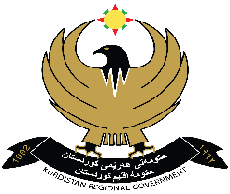
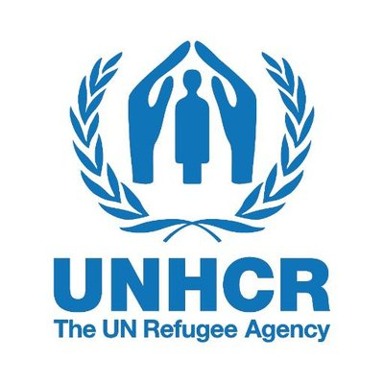
Duhok Directorate
General of Health

Project: “Primary Health Care and
Mental Health Psychosocial Support Services
for Syrian Refugees in Duhok Governorate” 2021
LETTEr of ivitation to Bid

REFERENCE: DOH/UNHCR/MeCOLAB/2021/01

28th september 2021
To whom it may concern,

Subject: “Supply of medicines, consumables and laboratory tests to Domiz 1, Domiz 2, Akre and Gawilan PHCs, Duhok Governorate, Kurdistan Region of Iraq” 2021
This is an invitation to bidder for the above mentioned supply contract.
Please find the following documents, which constitute the tender:
- Instructions to Bidders.
- Annex A (List of Medicines, Consumables and Laboratory Tests). to be signed, stamped and submitted in the technical envelop.
- Annex B (DoH Contract Conditions), to be signed, stamped and submitted in the technical envelop.
- Annex C (financial offer). to be signed, stamped and submitted in the financial envelop.
- Annex D (Delivery Plan).
Tender documents are available from the following internet address: http://www.duhokhealth.org/en (Directorate General of Health Website).
Bidders with questions regarding this tender should send them by email to doh.unhcr.2021@duhokhealth.org before 2^{h}. OCTOBER at 14:00PM.
Bids should be submitted in Two separated sealed envelops with subject “ Technical Offer or Financial Offer” is mentioned on or before 7th. OCTOBER at 14:00 pm (Duhok Time) to the following address:
DoH - UNHCR Coordination Office, Room 17, First Floor
Duhok Directorate General of Health, Duhok, Kurdistan Region, Iraq
Opening hours: Sunday – Thursday, 9:00 am – 2:00 pm
We look forward to receiving your tender before the submission deadline at the address specified. By submitting a tender you accept to receive notification of the outcome of the procedure by electronic means.
Yours sincerely,
Dr. Afrasiab M. Yones
Director General

